Experiment 12
Program:
import cv2
# Read the input image
image = cv2.imread("image.jpg")
# Check if image is loaded
if image is None:
print("Error: Image not found")
else:
# Rotate 270 degrees clockwise
rotated_image = cv2.rotate(image, cv2.ROTATE_90_COUNTERCLOCKWISE)
# Display original image
cv2.imshow("Original Image", image)
# Display rotated image
cv2.imshow("270 Degree Clockwise Rotation", rotated_image)
# Wait for key press
cv2.waitKey(0)
# Close all windows
cv2.destroyAllWindows()
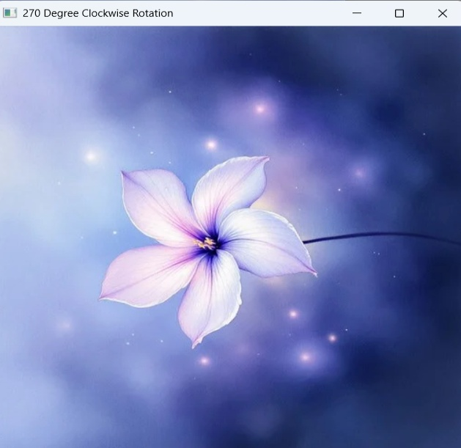
Output:

